NTU CISE DSD 2009 MIDTERMS (2009-11-18)

- Prove the identity of each of the following Boolean equations, using algebraic manipulation: (15%)
- x’y’ + x’y + xy = x’ + y
- a’b + b’c’ + ab +b’c = 1
- y + x’z + xy’ = x + y + z

- Determine the Q output for the negative-edge-triggered J-K flip-flop for the input waveform, and assume that Q=0 initially (10%)
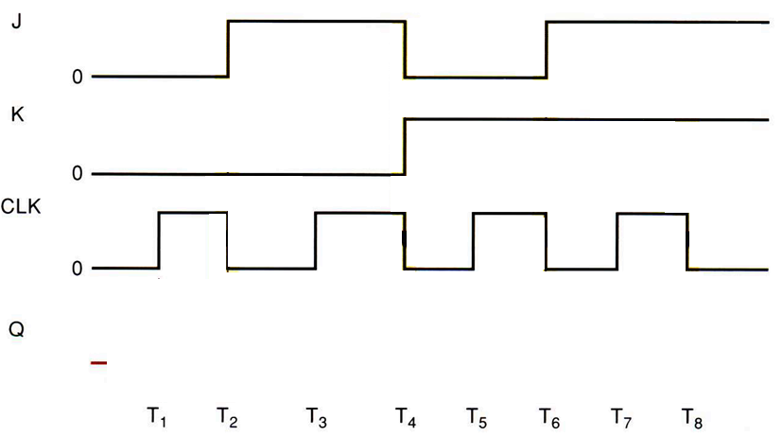

- Define half adder circuit and its truth table as below. Please combine two half adders to form a 3 input full adder circuit. (10%)
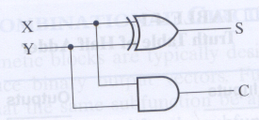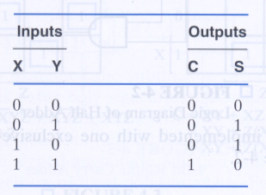
Half adder and its truth table
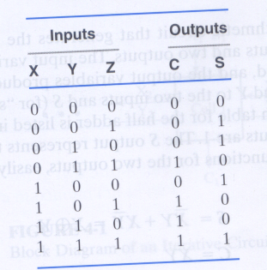
Truth table of full adder

- Find a function to detect an error in the representation of a decimal digit in BCD. In other words, write an equation with value 1 when the input are any one of the six unused bit combinations in the BCD code (10, 11, 12, 13, 14, 15), and value 0 otherwise. Please implement it with only NAND gates and inverters. (10%)
- Answer the questions
- Please describes that how to implement an I/O pin in digital logic system (5%)
- Please describes that how to implement rising-edge detector and falling edge-detector using basic logic gates (10%)
- Consider of EPROM and PAL, whick one is more programmable, and which one is faster, why? (5%)
- Use a PAL architecture to implement the following function. (5%)
C0 = AC + AB’
C1 = ABC’ + C
C2 = AB’ + C
- Please implement the functions on PLA (10%)
C0 = ∑m(0,1,2,4,5,6)
C1 = ∏M(0,1,2,3)
C2 = C’B’A + C’B’A’ + C'B + B'A
- (二選一題)
6.1 A clocked timing diagram is shown as below (Input X, State AB, Output Z), assuming raising edge is for clock trigger, Construct the state table and the state graph for the diagram. (20%)
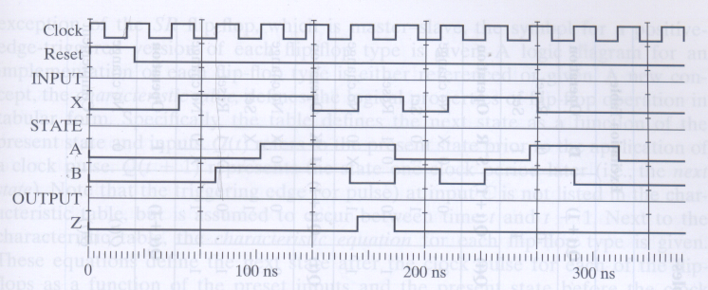
6.2 Please draw the waveform for the QA, QB, and QC of the following circuit and assume that QA, QB, and QC =0 initially (20%)
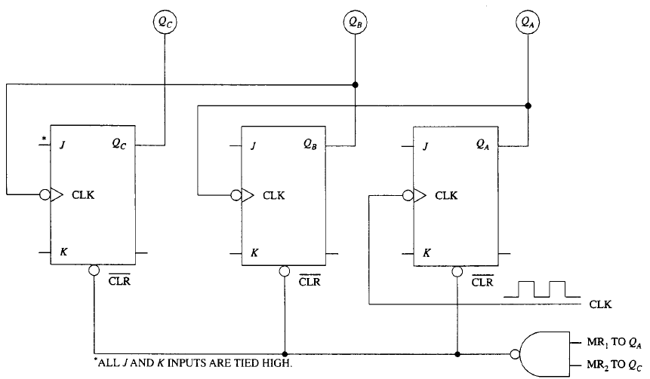
Note:
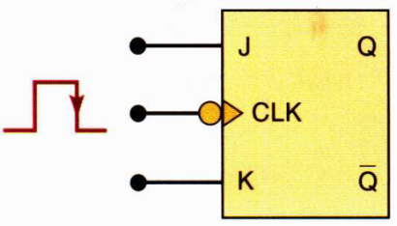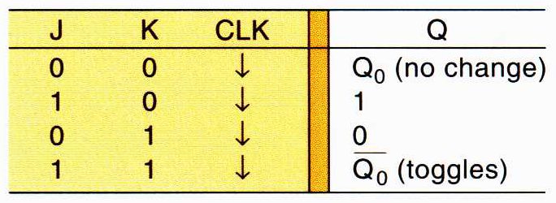

Answers of DSD 2009 MIDTERMS
1. Ans:
(a) x’y’ + x’y + xy = x’ + xy = (x’+x)(x’+y) = x’ + y
(b) a’b + b’c’ + ab + b’c = b + b’ = 1
(c) y + x’z + xy’ = x’z + (y+x)(y+y’) = x’z + y + x = y + (x’+x)(x+z) = x + y + z

2
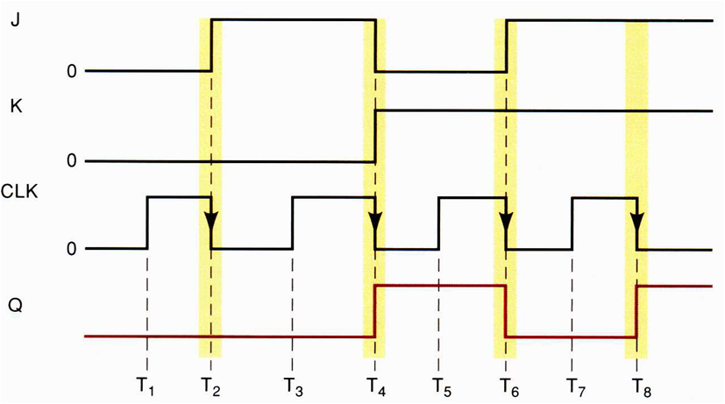
3
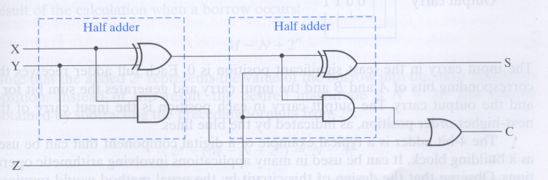
4
Truth table

5.a, By 3-State Buffer
5.b, Rising Edge
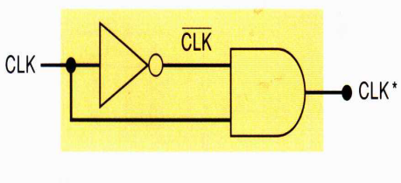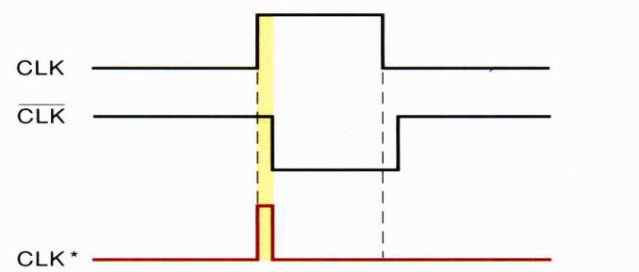
Falling Edge
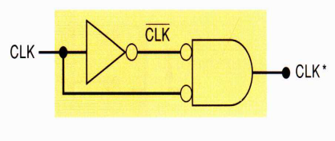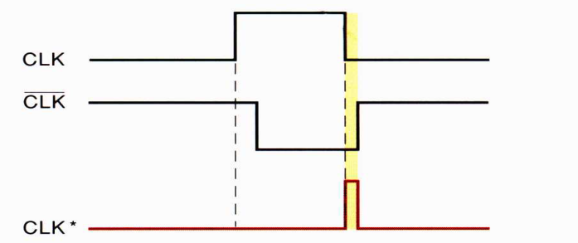
5.c
5.d
5.e
6.1
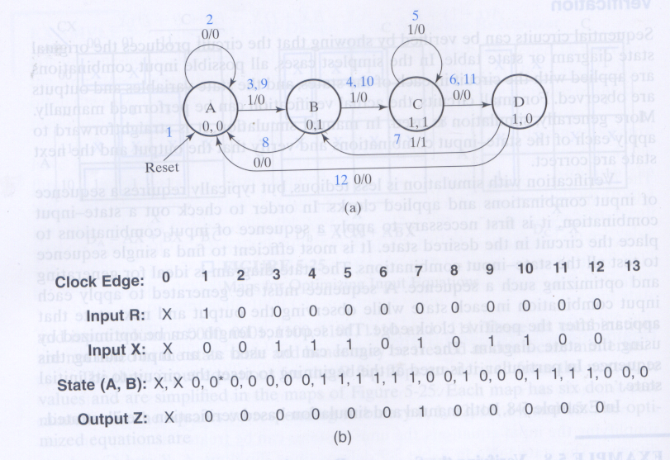
6.2
