Digital System Design Final Exam January 13, 2010
- (10%) In your opinion, how to save the budget in recent digital system products (considering the whole life cycle, from design to implementation)? Please provide at least two approaches to save the budget.

- (20%)
(15%)(a) Design a 3-bit bidirectional counter, using only JK flip-flops.
(A bidirectional counter is that when state is 000 and x = 1, it should go forward to state 001; when state is 000 and x = 0, it should go back to state 111)
(5%) (b) Implement a T flip-flop using only AND, OR, inverter gates, and RS flip-flops.

- (20%) Design a circuit for calculating the answer of a binary input sequence with modular 5 (mod 5) output, using only D flip-flops.(Hint : What is the state diagram for calculating the answer of the input sequence for mod 3? For example, 1101 mod 3 = 1. But this question is about mod 5, more complicated.)

- (20%) There is a MN Flip-Flop, which
  - if MN = 00, this flip-flop’s next state is 0,
  - if MN = 01, this flip-flop won’t change its state
  - if MN = 10, this flip-flop’s next state is the complement of present state,
  - if MN = 11, this flip-flop’s next state is 1,
    - Use present state (Q), next state(Q’) and input (M,N) to construct a table. (Notice: use don’t care term as possible as you can).
(b) Use derived table and K-Maps to design a counter which consists of three MN flip-flops, and it’s output sequence is as below:
ABC = 000, 010, 001, 100, 110, 000, 010, …
( c) If your counter starts from unsigned state, what will happen?

- (5%) In your programming assignment (team work) for design or reverse engineering, which part of your program is considered most time-consuming when you designed your codes? Based on the demos of your fellow students, if you were able to code it again, how will you change your coding in order to improve your results?

6. (20%) (a) (10%)Please find a minimum-state table that can replace the seven-state table given below. Assume that A is the initial (reset) state.
(10%)(b) Just use the RS Flip-flops to design the machine.

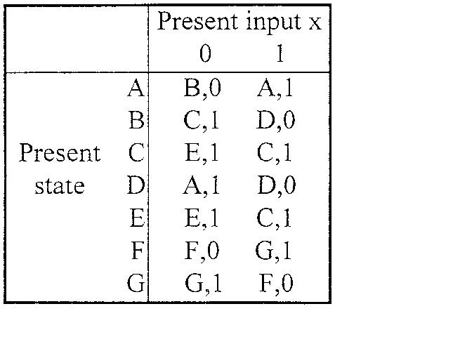

7. (5%) When comparing the Mealy and Moore machines, which one or two are asynchronous?
If it is asynchronous, how to make it synchronous by simply modifying the logic design slightly?

