1.
a) $X\overline{ Z}+\overline{X}YZ$

b) $BE+\overline{B}C\overline{E}+\overline{A}\overline{C}\overline{E}+\overline{B}D\overline{E}$
or $BE+\overline{B}C\overline{E}+\overline{A}\overline{C}\overline{E}+A\overline{B}D$

2.
a)
    - static 0-hazard and static 1-hazard
    - 說明其中一種即可
畫圖舉例說明
解法: 加上consensus terms
參考課本p.123~p.124 general strategy for static hazard elimination 那一段及example 3.12
b)
asymmetric delays of each of the multiple paths in a multi-level circuit
舉出例子可以產生dynamic hazard即可
參考課本p.126 ch 3.3.8
3.
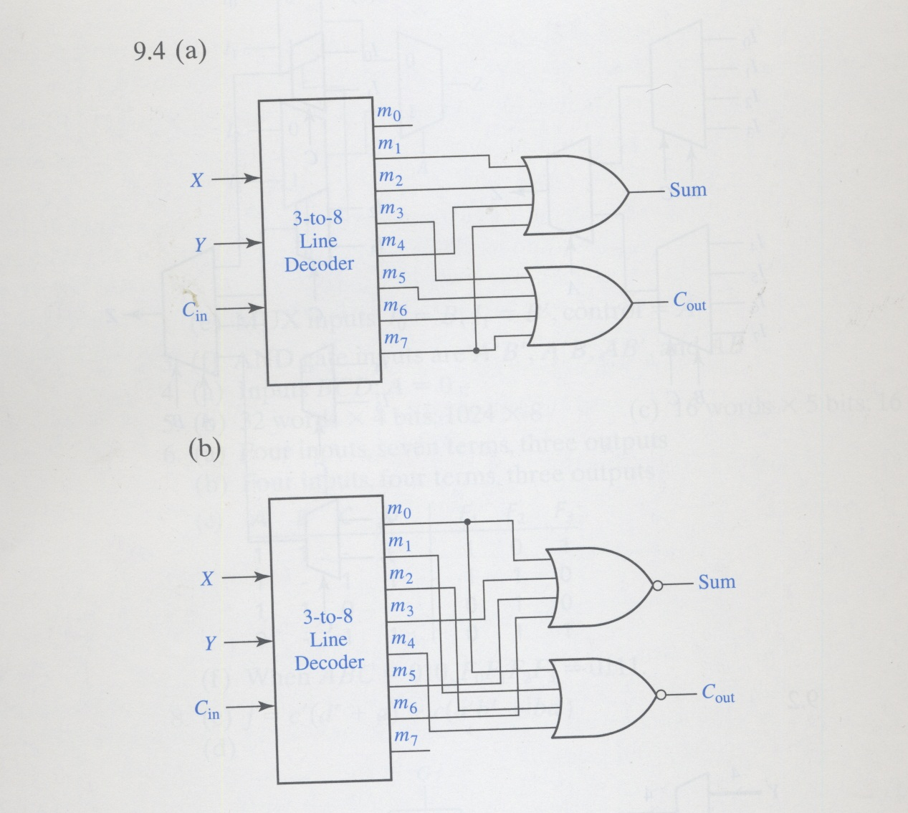

4.
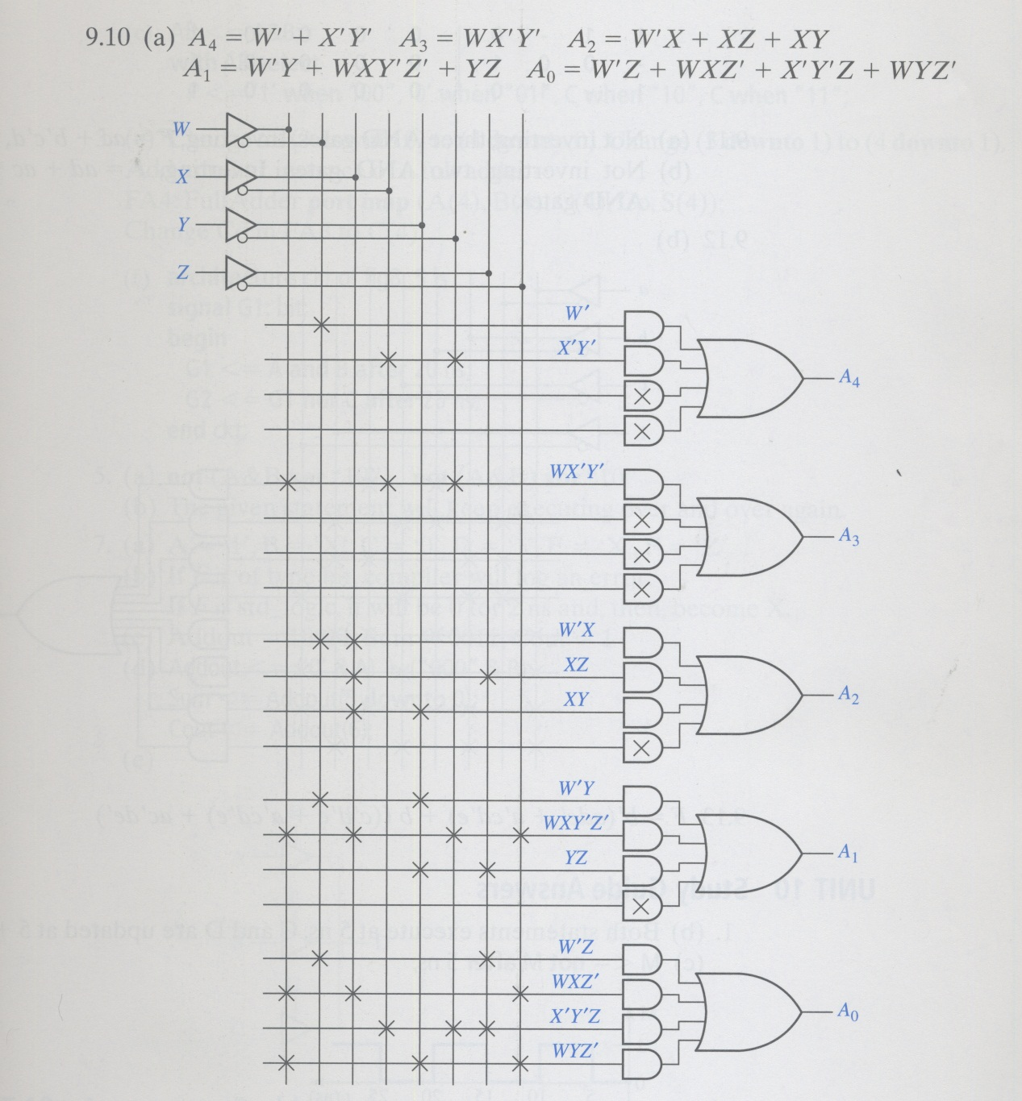

5.
CLk
Q_{C}
Q_{B}
Q_{A}
D

6.
a)
The circuit
D_{AA}
A
Y
D_{BA}
B
Z
X

The state table -- for D_{A}D_{B}Z value:

AB XY | 00 | 01 | 10 | 11
00 | 000 | 000 | 000 | 100
01 | 000 | 000 | 011 | 111
10 | 110 | 110 | 000 | 100
11 | 110 | 110 | 011 | 111

The state diagram
XY/Z: 10/1
XY/Z: 00/0, 01/0, 10/0
XY/Z: 00/0, 01/0
XY/Z: 00/0, 01/0, 11/1
XY/Z: 11/0
XY/Z: 00/0,01/0
D_{A}D_{B}
10
D_{A}D_{B}
11
D_{A}D_{B}
01

D_{A}D_{B}
00
00

XY/Z: 11/0
XY/Z: 11/1

XY/Z: 10/1
XY/Z: 10/0

Answer of 6
(a), 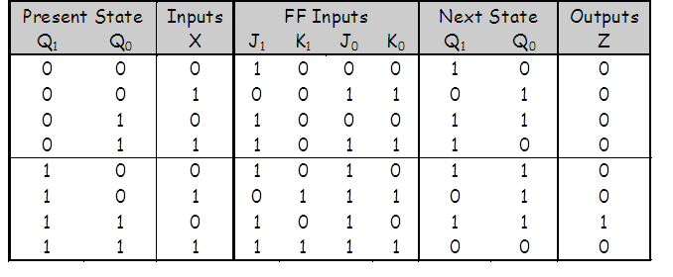
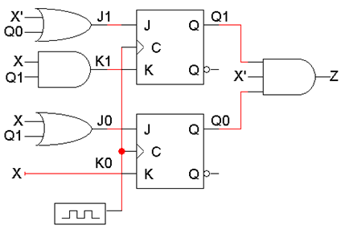
(b), 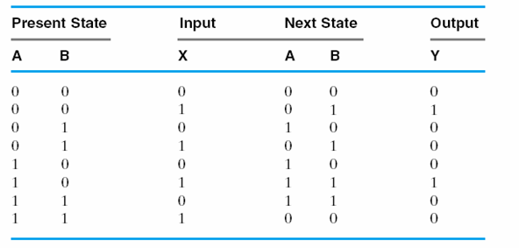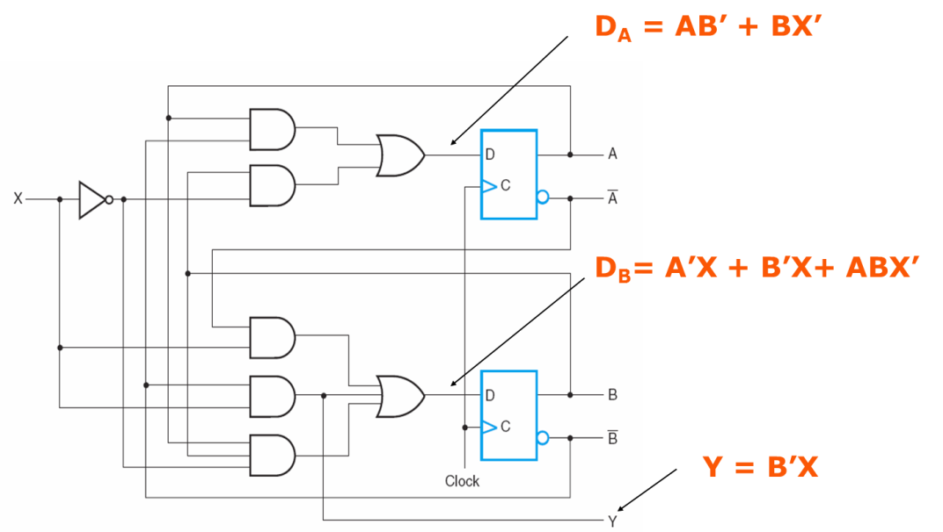

Answer of 7.a
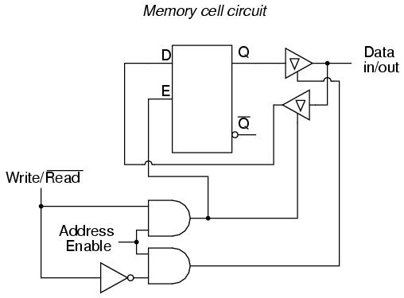
Answer of 7.b
Z = ABC + AD + C’D = A(BC+D) + C’D
Answer of 7.c
F = ABDE’ + A’B’ + C
= (A + B’)(A’ + BDE’) + C
= (A + B’ + C)(A’ + C + BDE’)
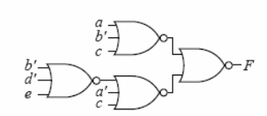

Answer of 8.a
F1 = Σ (3, 5, 6, 7) = (rows with F1 value of 1)
F2 = Σ (1, 4, 7) = (rows with F2 value of 1)

Answer of 8.b
F1 = Π (0, 1, 2, 4) = (rows with F1 value of 0)
F2 = Π (0, 2, 3, 5, 6) = (rows with F2 value of 0)
Answer of 9.a
ALARM = GD + G’L

Answer of 9.b
ALARM = GD + G’L
= ((GD)’(G’L)’)’

